Topic Knowledge Organiser: Year 3.
Spring 1 Topic: Ancient Greece
The Life and Times of Ancient Greece
Subjects I will cover in this topic:
History | Geography | Art | Design Technology |  |  | Music | RE | ICT
Reading | Writing | Maths | SEAL / PSHCE |  |  | Science | British Values | PE
Things I will learn during this topic:
- We can place Greece on a world map and show using an appropriate key how far Ancient Greek civilisation stretched across Europe and the wider geographical climate.
- We can place events, people and changes into chronological order on a timeline.
- We can explain about specific characteristic features of Ancient Greece, including the ideas, beliefs, attitudes and experiences of men, women and children in the past.
- We can look at a range of key Greek artefacts and ask questions about these items determining their use and importance.
- We can explore the importance of the ancient Parthenon temple, situated on the Athenian Acropolis.
- We can write a recount about our class trip using dates and vocabulary relating to the passing of time, including ancient, modern, BC, AD.
- We can explore a range of Greek myths for example: Jason and the Golden Fleece and Theseus and Minotaur and we can write our own.
- We can explore the different Gods and Goddesses the Ancient Greeks believed in, explain what they were responsible for and from this create our own Gods/Goddesses and mythical creatures.
- We can look at the patterns of Ancient Greece and can use them to inspire our own artwork.
Places I will visit, people that will help me learn and exciting things that will happen:
Class trip to Leeds Museum (Ancient Greece session).
I will learn about:
Mop of Ancient Greece – to explore how far the Ancient Greek civilisation stretched across Europe.  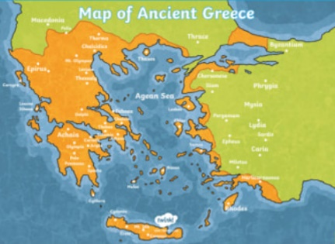 |  |  |  | Key figures of the Ancient Greek period  Leonidas Alexander the  Great Aristotle  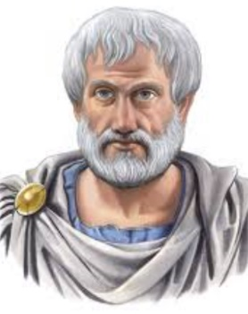  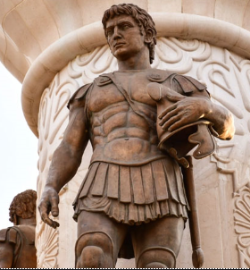  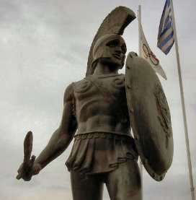
Key facts I need to know:
- The countries that were part of the Ancient Greek civilisation
- The roles Leonidas, Alexander the Great and Aristotle played during their time in the Ancient Greek period
- The key features of the period including home life, life of a soldier, a slave and life as a child
- Which Gods and Goddesses were worshipped during the time period and what were they responsible for
- The purpose of various artefacts we come across and what this tells about life for different people in Ancient Greece
- The importance of the Athenian temple Parthenon and how it was a dedication to Athena
Topic specific vocabulary I will use and learn the meaning of during this topic:
- philosopher |  |  |  |  | - republic
- civilisation |  |  |  |  | - modern
- BC and AD |  |  |  |  | - ancient
- myths |  |  |  |  | - slave
- legends
What do I want to know? What questions do I have?
Purpose/ End Product |  |  |  |  | To create an informative booklet about the Ancient Greeks to share at the end of the half term. To create some Ancient Greek artwork ie a mythical creature and to be able to retell a Greek myth.

