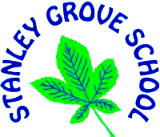
Topic Knowledge Organiser: Year 3.
Summer 2 Topic:
Victorians and Local History
Subjects I will cover in this topic:
History | Geography | Art | Design Technology |  |  | Music | RE | ICT
Reading | Writing | Maths | SEAL / PSHCE |  |  | Science | British Values | PE
Things I will learn during this topic:
- I will learn about William Morris and the Arts and Crafts movement and will study some of his designs.
- I will create repeating design printed patterns based on the designs of William Morris.
- I will be using tools and inventing, planning, making and engineering things as part of my outdoor learning experience.
- I will learn about famous explorers, scientists and engineers from Victorian period and from today.
- I will learn about the qualities those scientists needed to succeed and I will relate this to my achievement.
- I will learn about characteristic features of the Victorian period, including the ideas, beliefs, attitudes and experiences of men, women and children (in the context of investigating what our local area was like in the past).
- I will find out about coalmining in our local area and its significance for the Victorian people who were employed in the coalmining industry.
- I will use dates and historical vocabulary to describe the periods studied and to build up a timeline.
- I will investigate how our knowledge of the past is constructed from a range of sources (including ICT-based sources).
- I will write a biography of a famous Victorian.
- I will find out about Queen Victoria.
- I will use ICT to research and present information about the things I learn in this topic.

People I will learn about:
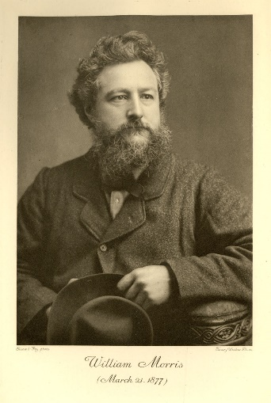  William Morris (24 March 1834 – 3 October 1896) was a British textile designer, poet, artist, printer, associated with the British Arts and Crafts Movement |  |  |  | 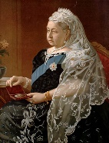  Queen Victoria (24 May 1819 – 22 January 1901) was Queen of the United Kingdom of Great Britain and Ireland
Key facts/questions:
- Who was William Morris?
- What did coalmining look like in our local area in Victorian times?
- What were some of the key inventions of the Victorian period?
- Who was Queen Victoria?
- Who were some of the people who shaped life in our local area in the Victorian period?
- What was life like for families in our local area during the Victorian period?
- What was life like for children in the Victorian period?
Topic specific vocabulary I will use and learn the meaning of during this topic:
- artefacts |  |  |  |  | - Victorian
- chronology |  |  |  |  | - invention
- reference book |  |  |  |  | - engineering
- investigate |  |  |  |  | - scientist
- interpret |  |  |  |  | - William Morris
- cause and effect |  |  |  |  | - Queen Victoria
- sources |  |  |  |  | - industry
- locality |  |  |  |  | - curious
- coalmining |  |  |  |  | - patient
- weaving |  |  |  |  | - creative
- printing |  |  |  |  | - perseverance
- communication |  |  |  |  | - open-minded
- teamwork/collaboration |  |  |  |  | - problem-solving
What do I want to know? What questions do I have?

